**MORIMOTO Project**

1. RFM Page:

From this page, According to given values the list of contacts will be shown up.

According to usage count of contact, usage charge of contact and the given start and end dates, the list of contacts will be displayed.

Vf Page: CustomerRankClone Controller: CustomerRank

Objects used:

1) Lead__c 2) AccountAcount__c 3) Contact 4) CustomerRANK__c

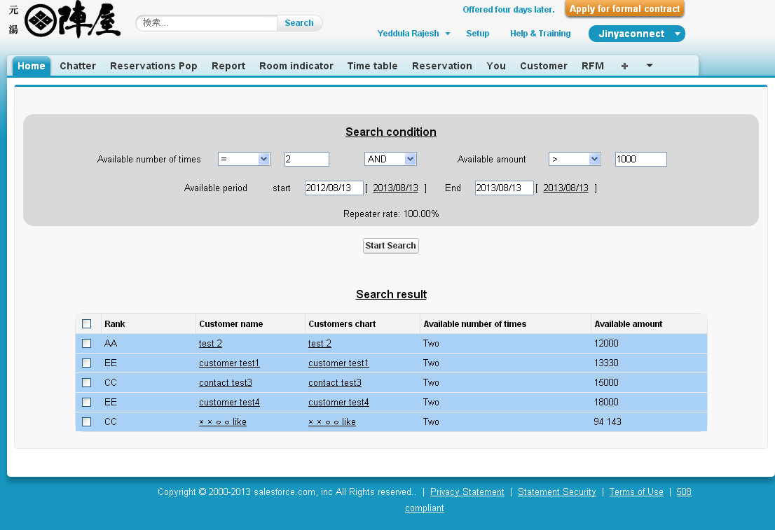

1. PDFgenerator page:

This page will be shown up when click on Customer name from RFM search page. In this page the customer details of count, charge and the graph showing the usage charge. On click of print icon, we can take printout of page.

VF Page: PDFGenerator Controller: CustomerRank

Objects Used:

1) Lead__c 2) AccountAcount__c 3) Contact 4) CustomerRANK__c

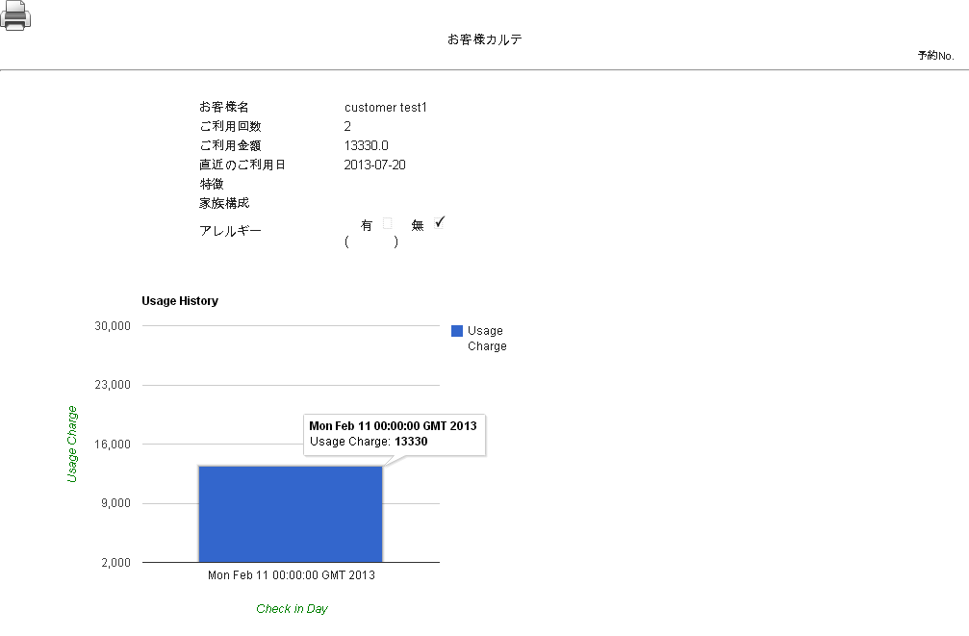

1. Booking Time Table Page:

From this page, we can view the booked reservations with customer name in the rooms on a selected date. From here also we can book the reserve the rooms for the customers by selecting arrival time to departure time. They can’t reserve the rooms which are already selected.

VF Page: BookingTimeTableVF Controller: BookingTimeTable

Objects Used:

1) Room__c 2) Lead__c 3) BookingTimeTable__c 4) AccountAcount__c

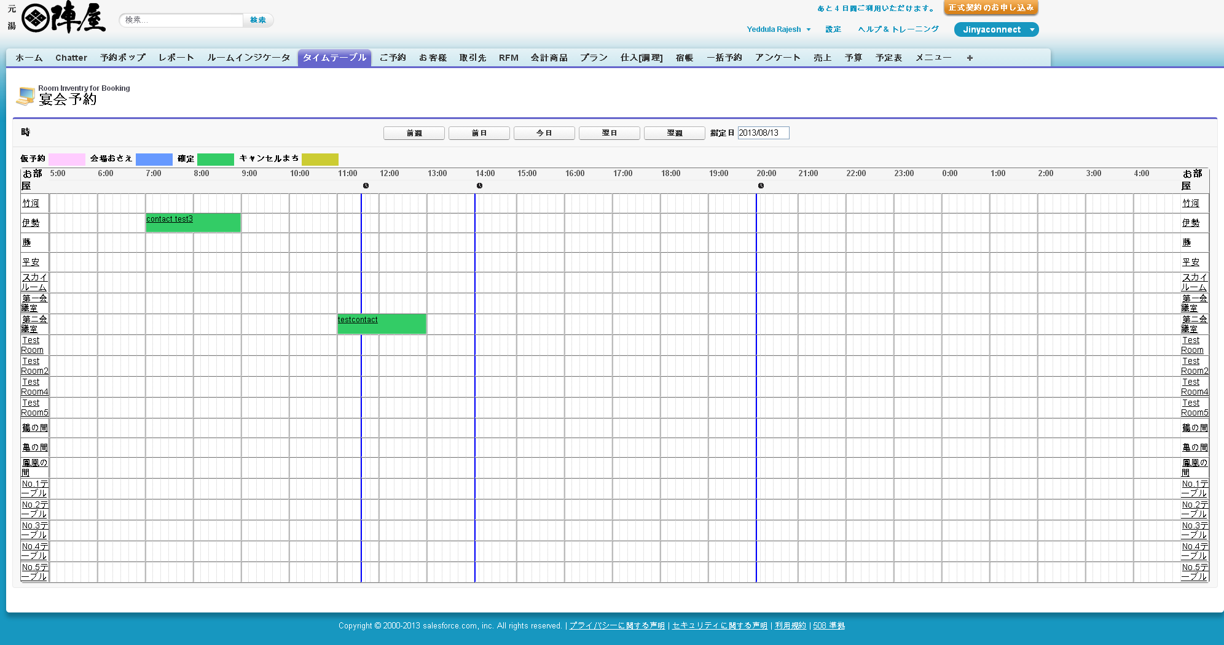

1. Room Indicator Info Page:

From this page, According to Hotel name and Room type all the rooms will be displayed under a particular building in a respective floor on a particular selected date.

VF Page: RoomIndicatorInfoNew Controller: RoomIndicatorInfoNew

Objects used:

1)Room__C 2)Lead__C 3) AccountAcount__c

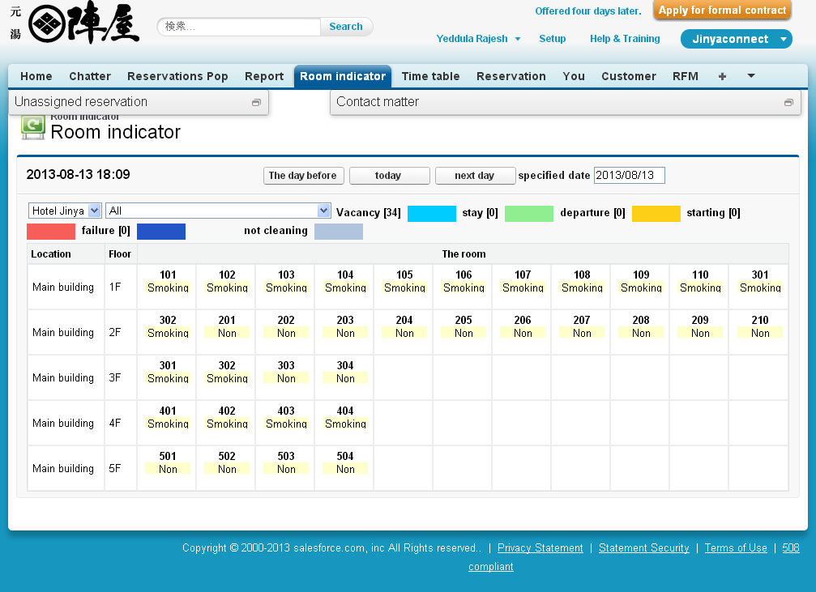

If the contact is present, that contact will be displayed on the room. See below image with blue color. Here you can shift that customer to another room by dragging.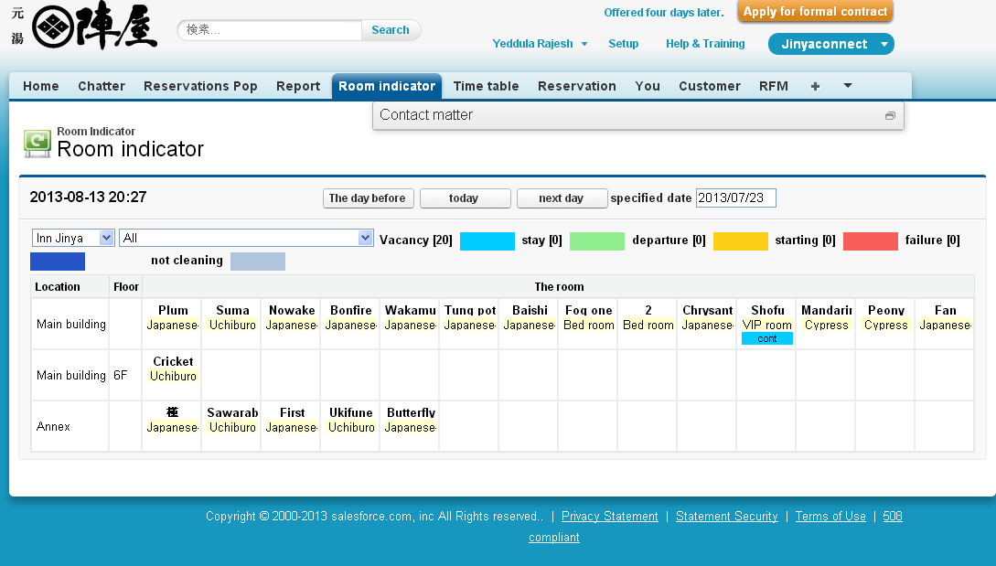

After customer name has dragged, that customer will be now shifted to another room.

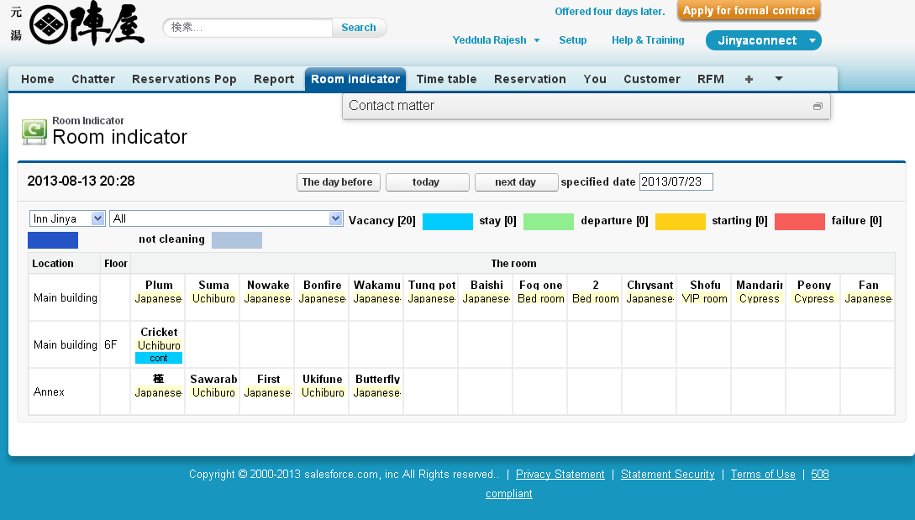

1. Accounting Edit Page (BillInput):

This Page will appear after accounting record is edited. From this page all the Accounting record data can be viewed and can be modify. At the bottom of page you can add multiple accounting lines by selecting item codes. Then finally click on save. All the modified data will be saved under particular accounting record.

VF Page: BillInput Controller: BillInput_ctrl

Objects used:

1) AccountAcount__c 2) TTend__c 3) Tran1__c 4) PlanDetail__c

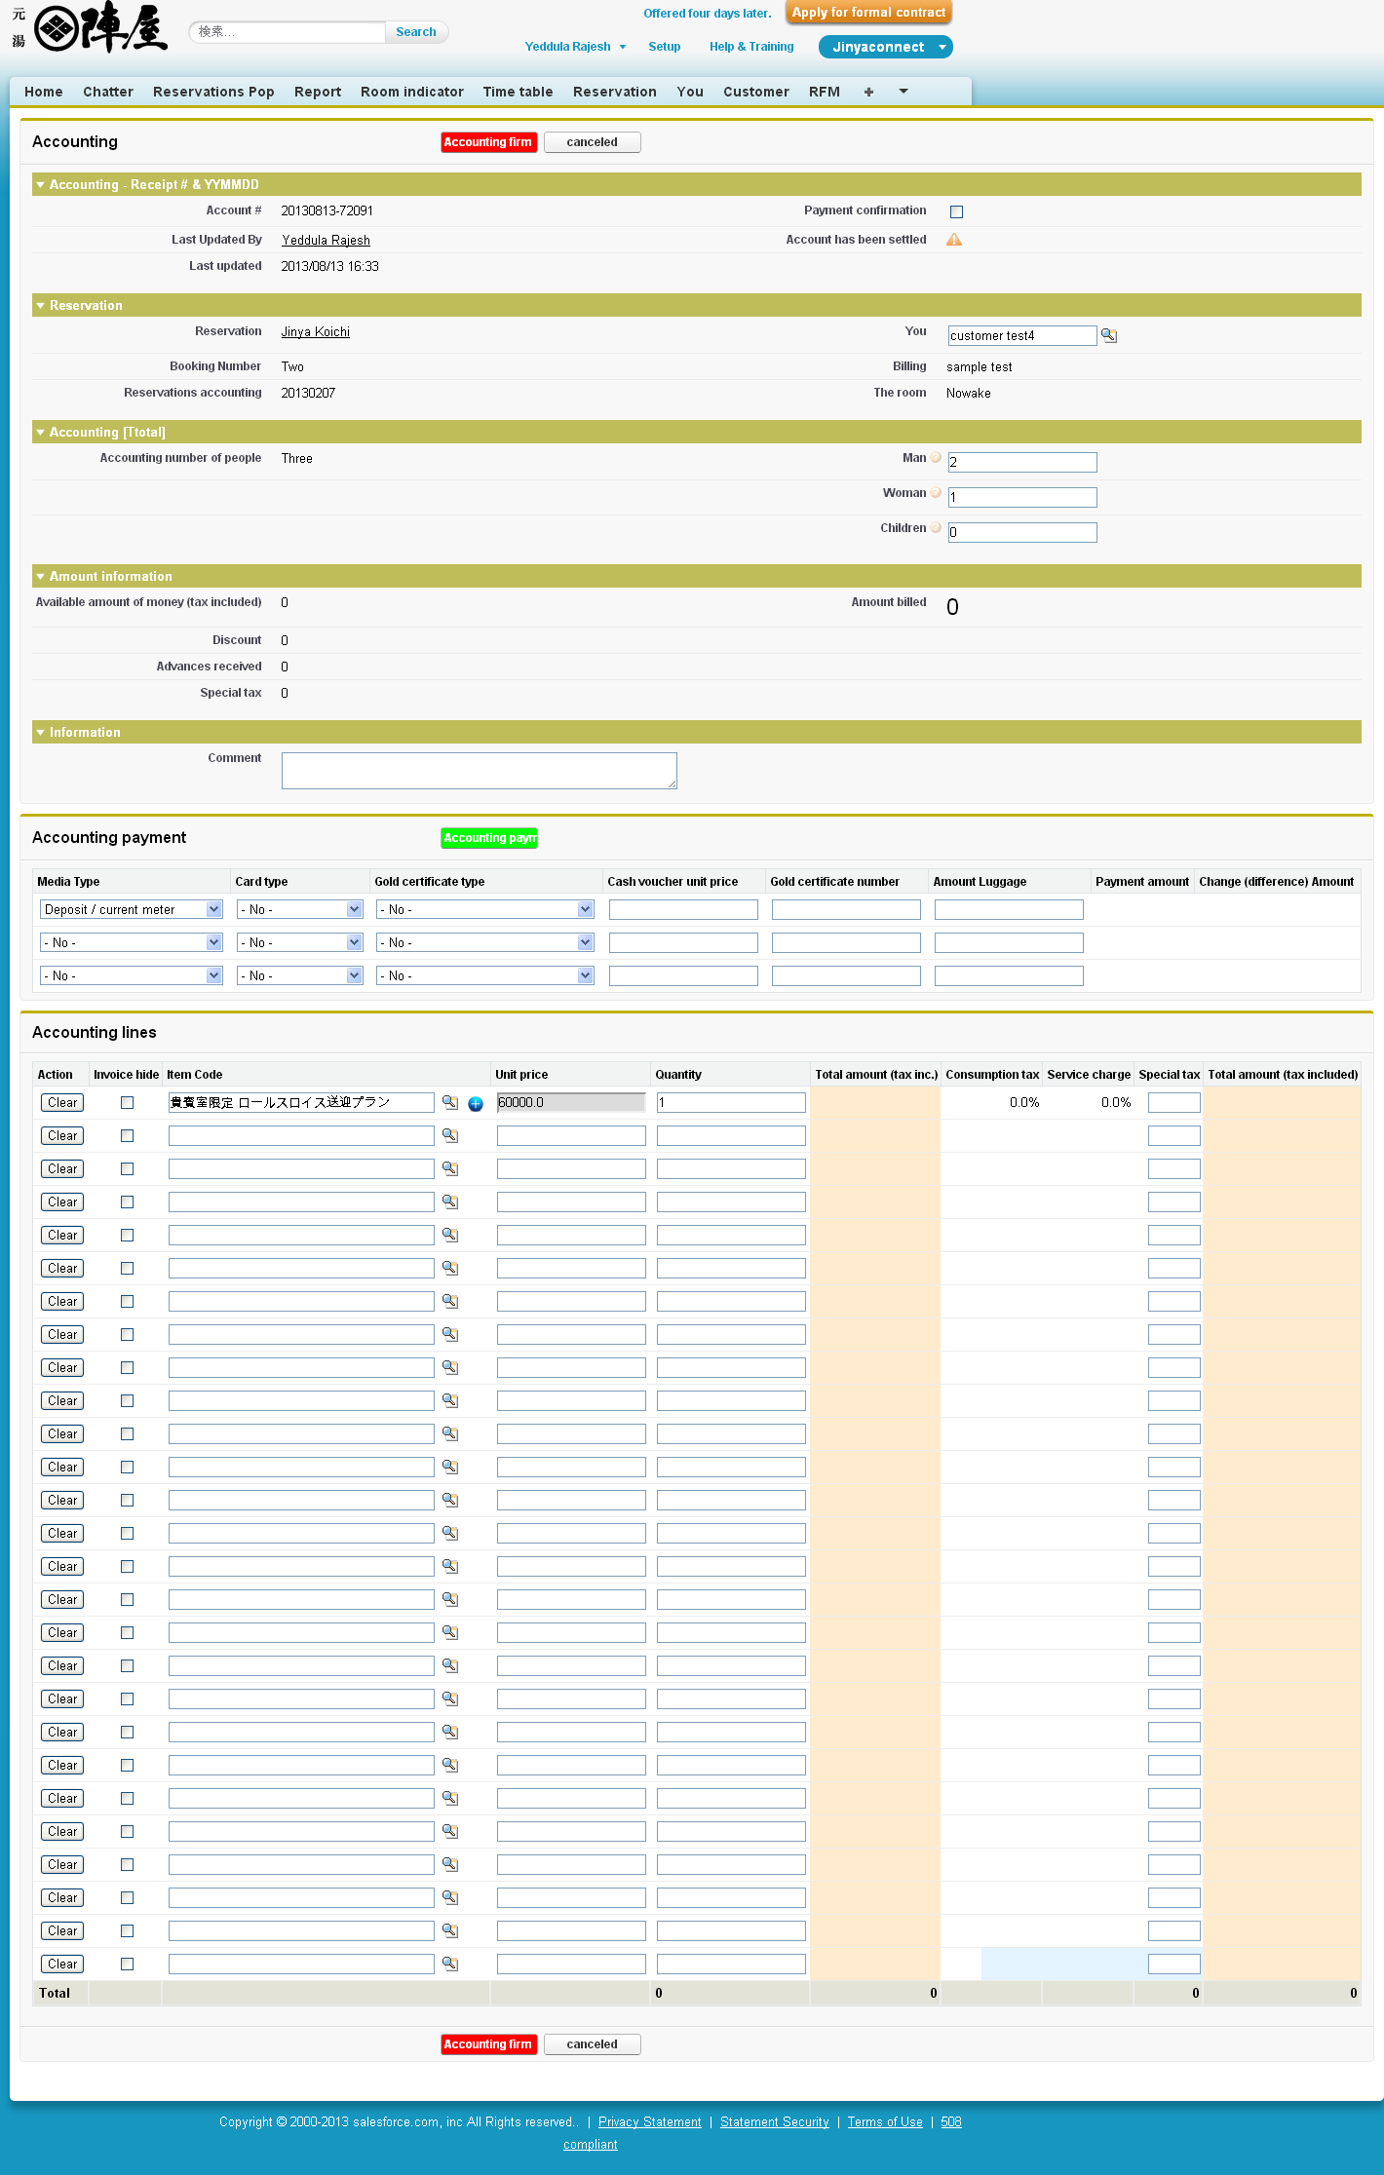

After save the record and again when accounting record is edited, all the details with sum of accounting lines will be shown up.

